**How to Completely Uninstall the Subsystem for Linux WSL on Windows**

[[](https://medium.com/@bonguides25?source=post_page-----24b0945050a0--------------------------------)](https://medium.com/@bonguides25?source=post_page-----24b0945050a0--------------------------------)

[bonguides.com](https://medium.com/@bonguides25?source=post_page-----24b0945050a0--------------------------------)

·

[Follow](https://medium.com/m/signin?actionUrl=https%3A%2F%2Fmedium.com%2F_%2Fsubscribe%2Fuser%2F8de5a3c0cb1a&operation=register&redirect=https%3A%2F%2Fmedium.com%2F%40bonguides25%2Fhow-to-completely-uninstall-the-subsystem-for-linux-wsl-on-windows-24b0945050a0&user=bonguides.com&userId=8de5a3c0cb1a&source=post_page-8de5a3c0cb1a----24b0945050a0---------------------post_header-----------)

2 min read

·

Jul 25, 2024

5

**Not a reader? Watch this related video tutorial:**

**Table of Contents**

In some cases, you want to completely uninstall the WSL Windows Subsystem for Linux in Windows 10/11. There are two ways to it:

* Uninstall WSL using PowerShell.
* Uninstall WSL from Windows Settings.

**Completely Uninstall the Subsystem for Linux (PowerShell)**

1. Right-click the Windows Start icon to open **Windows Terminal Admin.**In Windows 10, select **Windows PowerShell Admin** instead of Terminal.

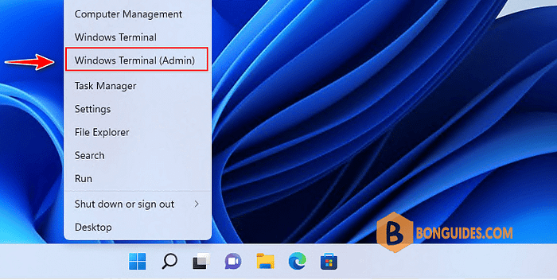

2. Run **wsl -l -v** to get the list of the installed WSL instances on your computer.

3. Next, remove the installed distributions using the **–unregister** parameter.

4. Re-run the wsl -l -v command to check if all the WSL instances got removed.

5. After running the unregister command, you can check the virtual hard disk is removed from this location:

C:\Users\<username>\AppData\Local\Packages\LocalState\

6. Search for **feature**, then open Turn Windows features on or off.

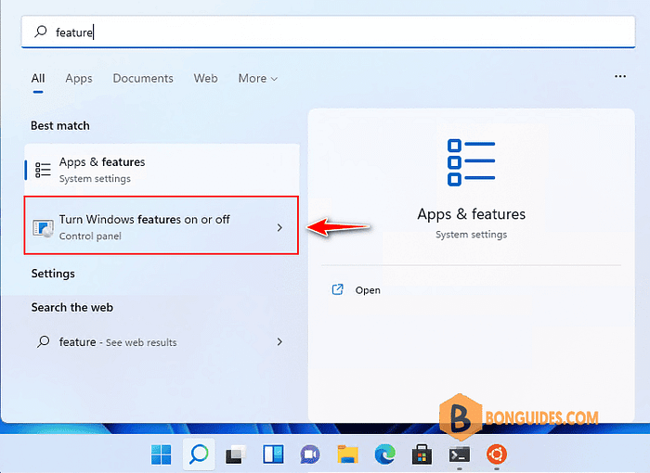

7. Finally, remove **Virtual Machine Platform** and **Windows Subsystem for Linux** features from Windows Features then restart your computer.

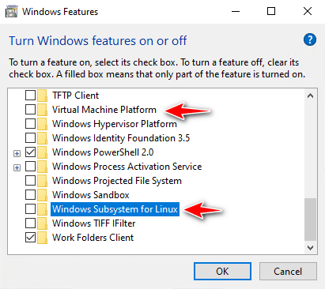

**Completely Uninstall the Subsystem for Linux (Windows Settings)**

Alternatively, you can remove the installed distributions from Apps and Features in Windows Settings.

1. Right-click on the Windows start icon, then select Apps and Features.

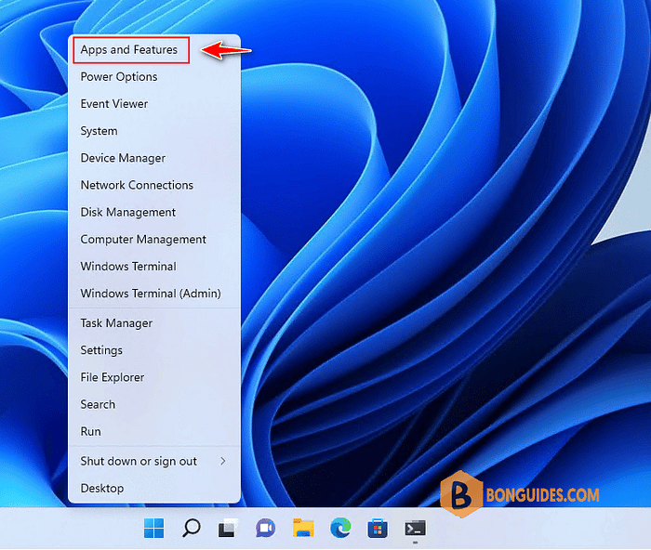

2. Under App & features, select the Linux distribution that you want to remove, then choose the **Uninstall**button.

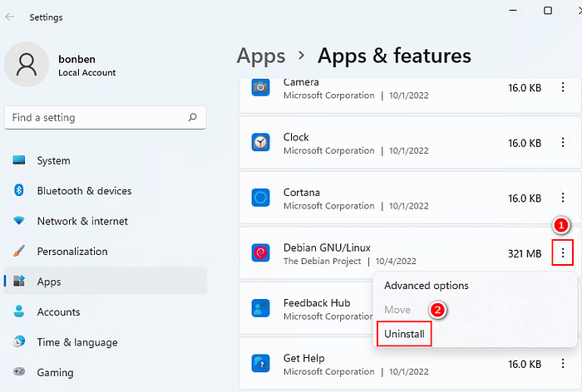

3. Once done, remove the **Virtual Machine Platform** and **Windows Subsystem for Linux** features from Windows Features to completely uninstall WSL in Windows 11.



<https://bonguides.com/how-to-completely-uninstall-the-subsystem-for-linux-wsl-on-windows/?feed_id=1268&_unique_id=66a1b79ae8849>